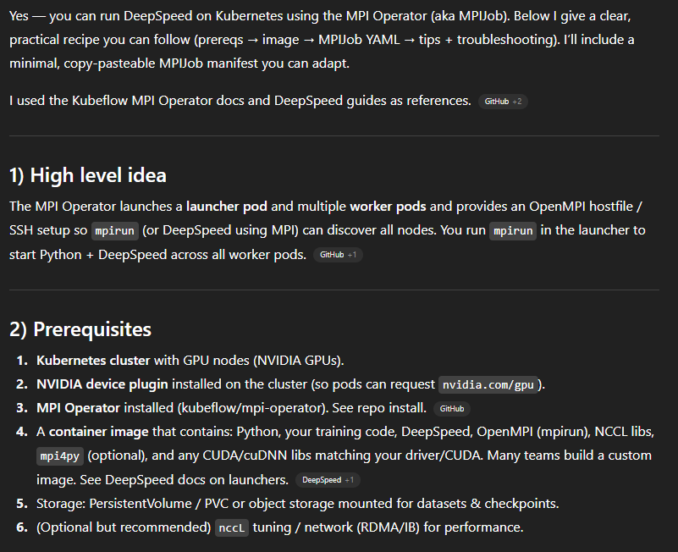
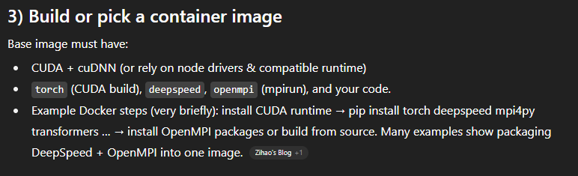
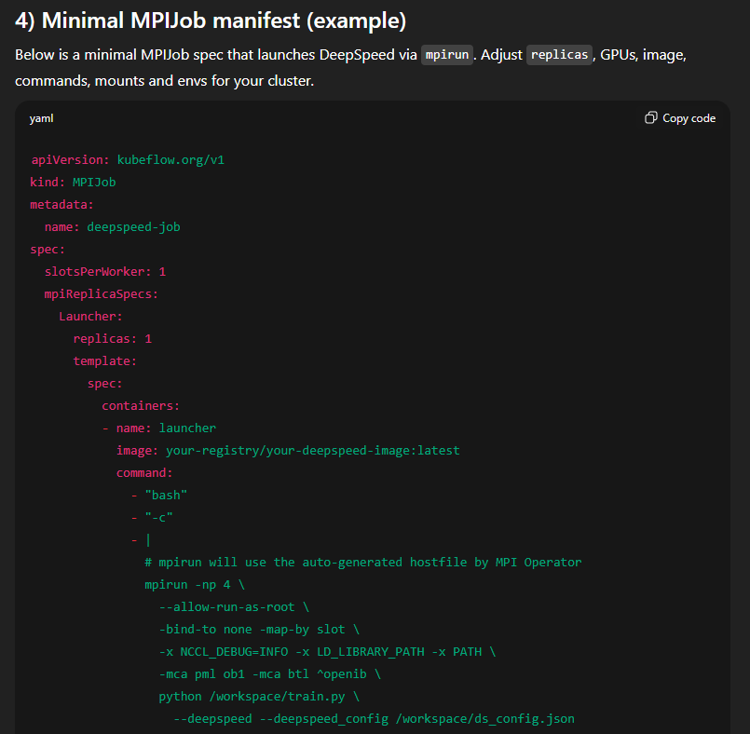
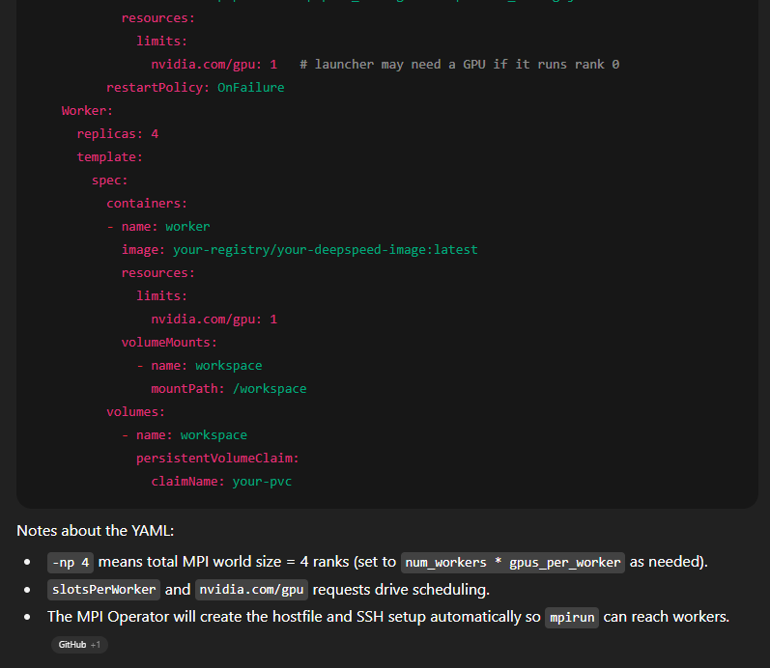
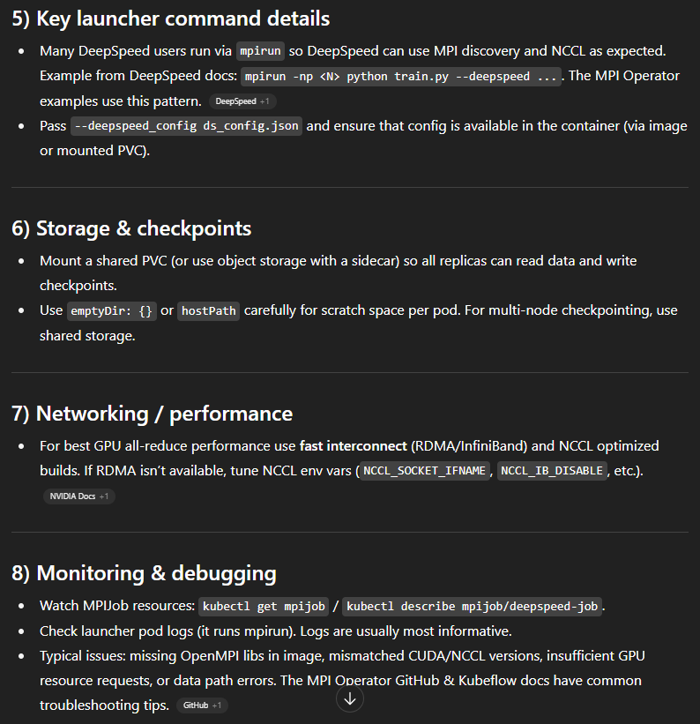
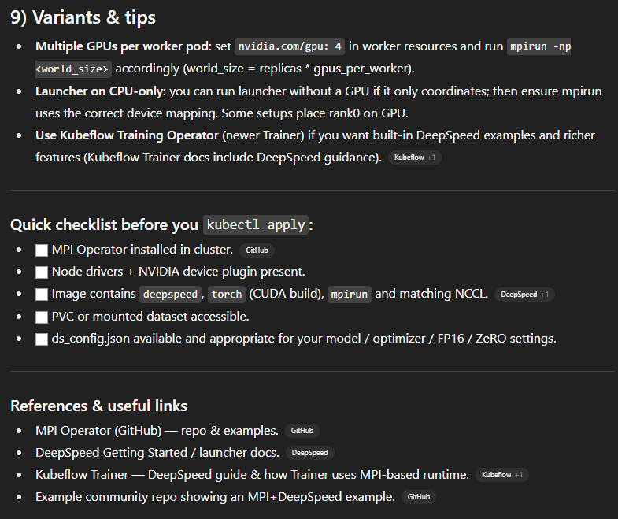
Links:
- MPI Operator (GitHub) — repo & examples - github.com/kubeflow/mpi-operator
- DeepSpeed Getting Started / launcher docs - deepspeed.ai/getting-started
- Kubeflow Trainer — DeepSpeed guide & how Trainer uses MPI-based runtime - kubeflow.org/docs/components/trainer
- Example community repo showing an MPI+DeepSpeed example - github.com/dtunai

